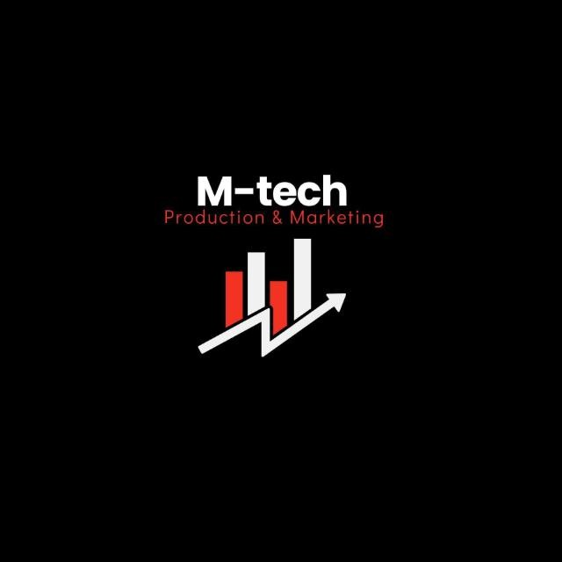

M-Tech Production & Marketing
Technology | Training | Marketing | Projects
TASK 13 REPORT
Internship Program — Batch 2026

Submitted By:
Hamza Badshah / Mtech-AI26028

Department:
AI / ML
Submitted To:
Ma’am Fatima
_______________________ | Supervisor:

Date:
17 July 2026
Haripur Main Bazar, Khyber Pakhtunkhwa, Pakistan
mtechproductionandmarketing@gmail.com | +92 336 2222480

Introduction

This report presents the work completed for Task 13 of the M-Tech Production & Marketing AI/ML Internship Program, Batch 2026. The internship focuses on practical exposure to core concepts in Artificial Intelligence and Machine Learning, equipping interns with skills applicable to real-world technology and marketing challenges.

M-Tech Production & Marketing is a forward-looking company based in Haripur, KPK, specializing in Technology, Training, Marketing, and Projects. The internship is structured in a 9-Phase roadmap designed to progressively build theoretical knowledge and hands-on project experience.

Objectives

- Understand the architecture and operation of Large Language Models, specifically the Transformer-based models.
- Master the "art" of prompt engineering to guide models toward specific, high-utility outcomes.
- Explore advanced prompting techniques, including zero-shot, few-shot, and chain-of-thought prompting.
- Learn to structure prompts with clear instructions, context, input data, and output formatting to maximize model performance.

Task Description

The task involves designing and refining prompts to solve complex problems without traditional coding. This includes setting system roles (personas), defining specific output schemas, and iterating on input phrasing to improve response accuracy. The goal is to develop "syntactic contracts" between the user input and the model output, treating prompts like structured API requests.

Work Done

- Prompt Architecture: Structured prompts using key components: Instruction (the task), Context (background information), Input Data (the specific query), and Output Format (the desired structure).

Technique Implementation:
- Zero-shot: Provided simple commands to evaluate baseline model intelligence.
- Few-shot: Included examples within the prompt to show the model the desired pattern or style.
- Chain-of-Thought (CoT): Instructed the model to "think step-by-step," forcing it to explain its reasoning before providing a final answer.
- Iterative Refinement: Experimented with varying levels of specificity and tone (formal vs. professional) to observe how phrasing constraints, such as word limits or specific milestones, impact response relevance.

Challenges Faced

- Ambiguity: Early, overly broad prompts resulted in generic or irrelevant outputs.
- Context Management: Handling long or "noisy" inputs required summarizing lengthy content or delegating processing to ensure the model did not lose track of the primary objective.
- Model Limitations: Encountered instances where the model struggled with nuanced tasks, necessitating a shift toward CoT prompting to improve logical accuracy.

Key Learnings

- Specificity is Key: Vague instructions lead to vague results. Clear boundaries, timeframes, and formatting rules are essential for usable outputs.
- Iterative Design: Prompt engineering is not a one-time task; it requires testing, evaluation, and refinement to achieve reliable results at scale.
- Contextual Anchoring: Assigning a "system role" (e.g., "You are an expert AI engineer") significantly helps anchor the model’s behavior and improves the quality of technical responses.

Conclusion

Experiment 13 successfully demonstrated that effective communication with AI is as vital as the underlying model architecture. By mastering prompt engineering, I have gained a powerful, low-code tool to accelerate development, improve documentation, and solve complex logic problems. These skills are directly applicable to the diverse technology and marketing projects supported at M-Tech.

Intern Signature: | __Hamza Badshah __ | Supervisor: | _______________________
Name: | Hamza Badshah | Name:
Date: | 17 July 2026 | Designation:

